Wake for Remote Access
Open IE or any browser in citrix enter below URL
http://vwodsema001/WRA/
- Enter your PC IP address in computer name section and hit search
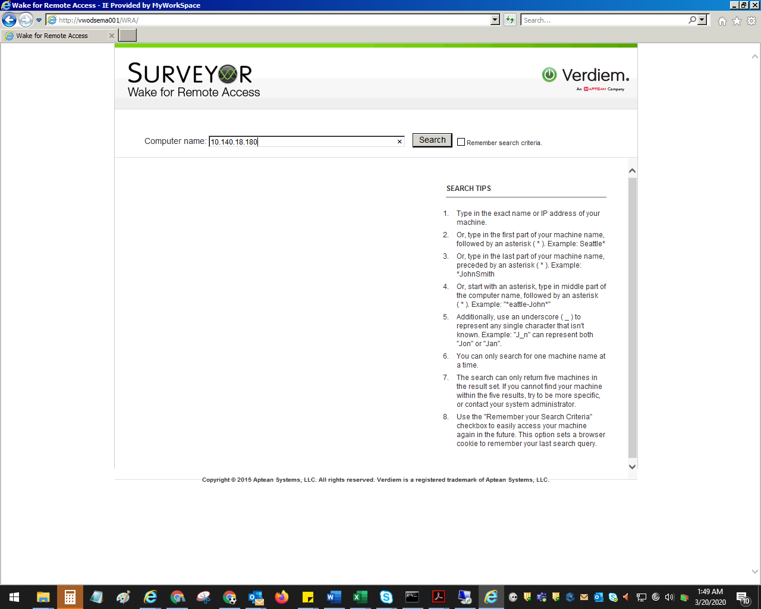

- Click on wake to turn on remote system.
- Once you get ping reply your PC is on
